**CubeSat Electronic Boards Design**

By:

A. Wong

J. Sands

K. Mody

P. Zwinkels

Faculty Advisor: Dr. Jayshri Sabarinathan

ECE 4416 Electrical/Computer Engineering Project

**Midterm Progress Report**

Department of Electrical and Computer Engineering

Western University

London, Ontario, Canada

## 

# **1. Introduction/Background**

## 1.1 Problem Statement

The custom made boards within the Cubesat must be designed to contain all of the necessary components, including an automatic timer, burn wire circuit, and magnetorquers, amongst other pre selected components. The boards must also integrate properly with the existing selected hardware, such as the on board computer (OBC) and the power supply. Our design, and the parts we select for them, must also meet the safety requirements set by the Canadian Space Agency (CSA) in order to be safely used in space. [1]

## 1.2 Detailed Literature Review

The University of Western Ontario, in collaboration with Nunavut Arctic College, has received a grant among several other post-secondary institutions from the Canadian Space Agency, to build a satellite as part of their CubeSat Program. This satellite is 10cm x 10cm x 10cm in total volume, weighing about 1kg in a square shape (roughly the size of a rubix cube). [2] The Canadian CubeSat Project (CCP) was announced in April 2017 and has already begun. [3] It will be completed with the launch of the satellite in 2021.

The first, and most important, documents we reviewed when starting our capstone project was the safety guidelines set out by CSA. As our designs would be sent into an extreme environment, we needed to ensure it met all of the specifications to not only function properly, but also not endanger or compromise any people or other equipment involved. This mainly involved watching webinar videos we were provided by our advisor [4], as well as speaking with our advisor and CSA representatives when given the opportunity. [5]

After this, we began to look through the documentation of past and current parties involved with the Cubesat project, and their work. All of the documentation and their revisions for this project have been stored on a GitHub space, which we began looking through after we were given access. [6] We were especially interested in documents related to the magnetorquers, on board computer, and power supply, and antenna deployment system. Most of these major components had already been selected, so our design was directly affected by them. [7]

Once we had finished reviewing the current documentation, we began researching the components that we were required to select and add to the custom boards. Some of the major parts included the timer, the antenna release system, and power and computing systems we would be using. The timer would be needed to delay the supply of power to the CubeSat so that it would not interfere with the International Space Station from which it is planned to be launched. CSA guidelines state that a time of 30 minutes must pass after deployment before the device may activate. The antenna release system is also important for safety reasons. If they antennae deploy too early they could injure someone or damage other equipment.

1.3 Project Objectives

We wish to design, build and test two custom electronic boards to be used in the CubeSat satellite. These boards will contain three magnetorquers that will control the satellite's orientation, as well as detumble it after it is launched from the International Space Station. The boards will also interface with all of the CubeSat components, allowing data to be sent and received as required. The end goal of this is to produce 360 degree photos from the orbiting satellite using two 180 degree cameras mounted on both ends. [8]

By collaborating with other teams, we will integrate all parts of the CubeSat together. Having knowledge of the ADCS team’s work is crucial for the success of our part. By having the specifications of the magnetorquers, we can design our board around the size of the components. [9] We also want to connect the on board computer with the output of the 555 timer to activate the burn wire circuit; the antennae are required to safely deploy after 30 minutes.

From this capstone project, we wish to gain a better understanding of space-rated circuit design as well as working with large organizations. By gaining experience in this domain, we complement our degrees and learn valuable information that can later be applied in industry. Our goal is to successfully integrate our custom electronic boards and fulfill our duty to the electrical portion to the project.

# **2. Design Approach**

2.1 Concept Generation

The CubeSat circuit boards act as the connection between the major components of the CubeSat. These components include magnetorquers, gyroscopes, on-board computer (OBC) and electrical power system (EPS) among others. The OBC has many connection methods which allow many components to be run by it. The EPS is the main power supply for the device and all components. The gyroscopes detect the attitude of the CubeSat and the magnetorquers allow the CubeSat to adjust its attitude when required. All components must be space-rated to account for the unique conditions the CubeSat will face in orbit.

After the CubeSat is switched on, there will be a delay before our boards receive power. This is so that it does not power on prematurely, and can be launched from the International Space Station safely. Based on the Canadian Space Agency’s requirements, a thirty minute timer needs to be added between our boards and the main power supply. Through discussions with our advisor, as well as analyzing past CubeSat and similar missions, we selected to use a 555 IC timer. [10] We then researched into the different modes and configurations of these timers, settling on two of them, monostable and astable modes. From these, we proceeded to test and compare these two to determine which was most suitable for our project.

2.2 Concept Evaluation and Selection

**PCB Specifications**

Before beginning the preliminary PCB designs, it was important to first research the rules for creating multi-layered circuit boards, because we had no experience creating any in the past. The first thing we learned is that it is recommended to only use an even number of layers on our boards. This prevents unwanted warping or damage during soldering or usage. With this in mind, we had the options to design two 2-layer or 4 layer boards. [11] We decided to select the 4-layer option as it offered more physical space to develop on, and a power and ground plane to power our components. A power plane is a flat layer of a conductive material, often copper, that is connected to the power supply. A ground plane is similar except it instead connects to ground. In order to connect our components to these planes, we will route to them using ‘via’s’ or ‘vertical interconnect accesses.’ These are essentially a hole in the board, lined with a conducting material to carry a current. Our final two layers would be the signal layers which would be made up of routes from components to the other planes. The signals planes lie on the outer layers of each board and the power and ground layers are located between them for ease of access. Our design will use components that operate at 5V and 3.3V so we have chosen to implement a split power plane. [12] This is a power plane with two isolated regions, each connected to a different voltage supply. This will allow us to access both necessary voltages without needing to convert using resistors.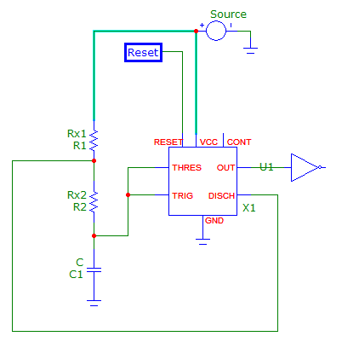

**555 Timer**

For our 555 timer, we began by comparing the two possible modes. The first option was astable mode. This is set up by connecting a resistor between the voltage source and the discharge pin of the timer, and another between the discharge pin and the threshold and trigger pins of the timer. A capacitor is also added between the threshold and trigger pins, and ground. When the circuit is powered, the capacitor is slowly charged. When it reaches ⅔ of the supplied voltage, it will begin discharging. Because of the configuration of the circuit and the pins that are connected, while the capacitor is discharging, the output of the timer circuit switched from high to low. When the charge in the capacitor reaches ⅓ for the supplied voltage, it begins charging again, which causes the output to switch back to high, and repeat the process. [13] By manipulating the size of the resistors and capacitor, you can control the period which it is outputting a high or low result. [14] The width of the high portion of the output is defined by Th = 0.693*(R1 + R2 )*C, where Th is the time in seconds, R1 and R2 are the resistance of the resistors, and C is the capacitance. The width of the low portion of the output is defined by Th = 0.693* R2*C. [15] Astable mode is completely autonomous, requiring no external inputs from the user, but produces a periodic square waveform, which was not as ideal for our application. 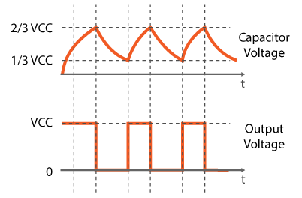

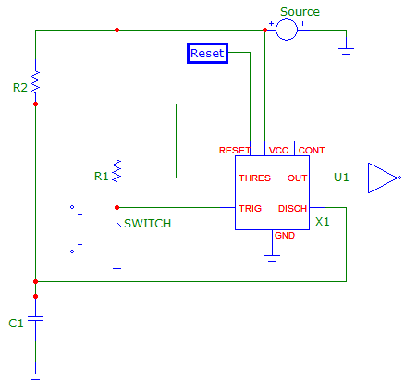

The other mode we considered using was monostable mode. To set the timer in monostable mode, a resistor is added between the voltage source and the trigger pin, with a switch between the trigger pin and ground. Another resistor is placed between the voltage source and discharge and threshold pins, in parallel with the first resistor. A capacitor is placed in series with the second resistor, between the discharge and threshold pins, and the ground. [13] This mode is once again controlled by the charging of the capacitor. After the circuit is connected to power, after the push button below the trigger pin is pushed, the capacitor will begin charging. As it begins charging, the output of the circuit switches from low to high. It will remain this way until the capacitor reaches ⅔ of the supplied voltage, after which the capacitor rapidly discharges, and the output returns to low. The circuit remains like this until the switch is pressed again. [14] The width of this pulse pulse is defined by t = 1.1*C*R2, where t is the time in seconds, C is the capacitance, and R2 is the resistor in series with the capacitor. [16] Monostable mode produces a single pulse, before remaining constant, which fit our design better, but had a short period during its startup that would potentially power up the boards too early. 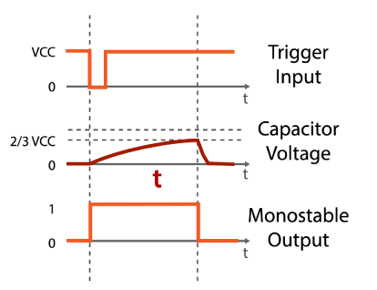

After consulting with our advisor, we decided to proceed with the monostable mode design, as the startup period could be easily controlled and shortened, and the single pulse was easier to design around versus the periodic waveform. From these, we began looking into parts for the external circuit to set the timer in monostable mode.

**Burn-Wire Circuit**

A burn-wire circuit consists of a wire that is heated up to a point where it breaks, to release a mechanism. Once the 555 timer has completed, a release mechanism is activated to deploy the antenna on the corners of one side of the CubeSat. This is where the concept of a burn-wire addition to the circuit comes into play. This wire, made from Nichrome (Nickel-Chromium, sometimes with small alloy impurities) has a 4.7-Ohm resistor intertwined in its threads. [17] This release solution is chosen due to it being able to be cleanly actuated with inexpensive electronics, and it can be operated with standard CubeSat bus power (5-volt source). This burn wire, pulled tight under high tension, is simplistic enough to implement, and is affordable under our budget. The mechanism uses a compression spring system to apply a stroke as well as a force to the nichrome wire. In order for the nichrome wire to begin burning, an AND-gate is required to have the thirty-minute timer completed its time, as well as confirmation from the OBC (On-Board-Computer) via a microcontroller to be managed from Earth. When the battery source is connected and has its current flow through this wire, it will thermally cut through the Vectran cable tie–down, a manufactured LCP (Liquid-crystal polymer). Once the Vectran tie-down is severed, it deploys the antennas of the CubeSat.

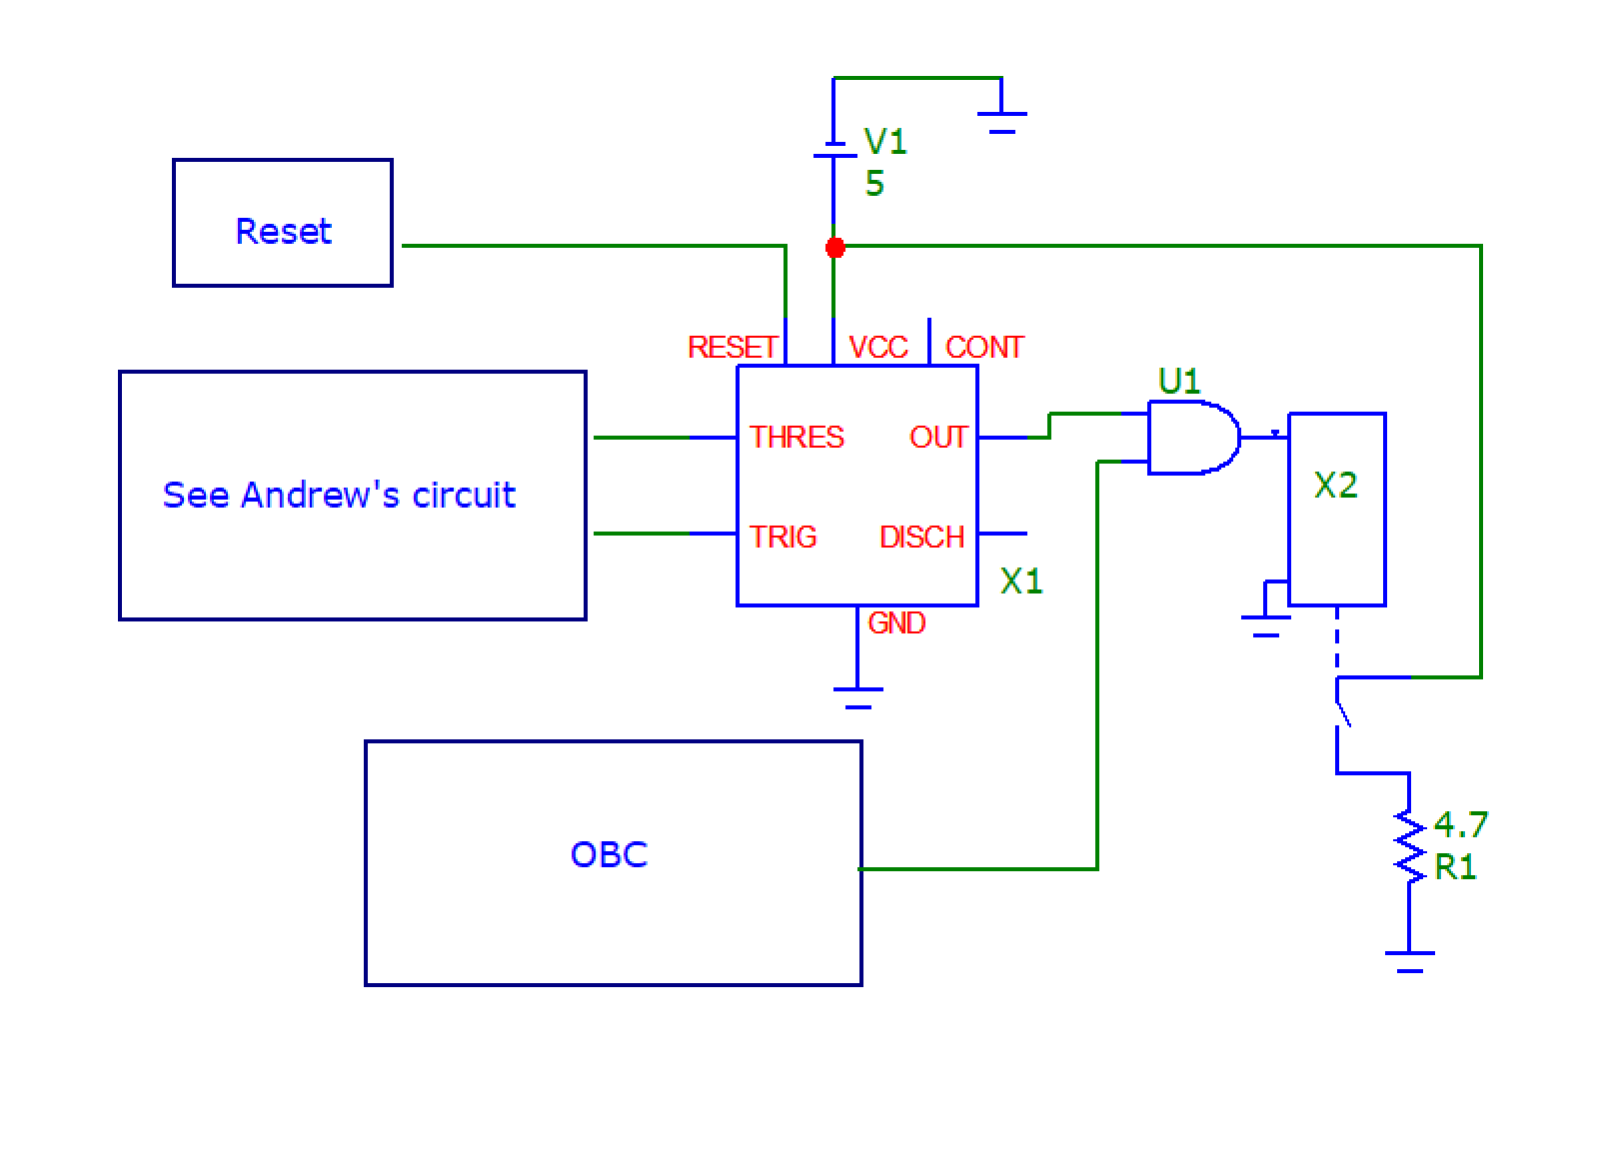

*Figure: Burn Wire Circuit*

Above shows the system involving the 555 timer and the burn wire mechanism, in the form of MicroCap circuit. The source voltage V1 (5 volts) enters the 555 timer and begins the thirty-minute countdown. Due to the output of the timer as well as a microcontroller on the OBC (On-Board-Computer) being inputted into an AND gate, the wire, represented as R1, will not begin to burn from the sources current confirmed by both the thirty minutes being concluded as well as verification from the OBC. This then closes the switch and sends current through the represented nichrome wire [18].

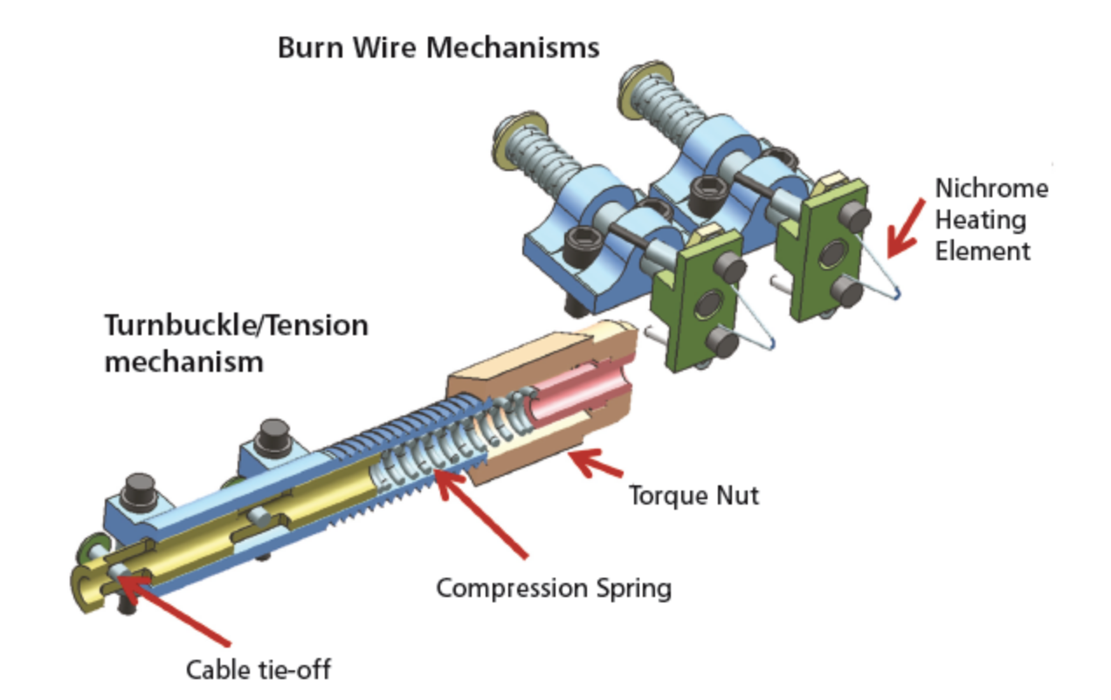

*Figure: Isometric view of Burn Wire Mechanism*

The figure shown above is an isometric view of the system of the burn wire system. Its three most significant components are the cable tie-down, a tension apparatus as well as a mechanism for burn wire actuation. The nichrome heating element rises in temperature until it burns the nichrome and breaks the Vectran tie-down cable. This is not the final design option, as the weight might be too high or have a lack of space on the CubeSat. The final design will be put forward during the testing phase.

**Interfaces**

The components included on our PCB boards make use of a variety of communication interfaces. These include SPI, PWM and I2C. The gyroscopes operate via SPI or Serial Peripheral Interface. SPI is a synchronous bus which includes a clock to keep the distributing and receiving ends in sync with one another. The clock is an oscillating signal which notifies the receiver when it must sample bits on the data line (either at the rising or falling edge). For SPI, only the transmitter creates a clock. PWM stands for Pulse Width Modulation, and is essentially a rapidly cycling switch to regulate the power distributed to a device. Our ADCS system sends power to our board via PWM to the magnetorquers to adjust the CubeSat’s attitude. I2C is a two wire system allowing a ‘master’ device to send signals to multiple ‘slave’ devices which each have a unique address associated with them. By including this address in the data line, the master can transmit information exclusively to a selected device. I2C will be used by our antennae, GPS and transceiver systems.

**3. Preliminary Analysis**

3.1 Engineering Techniques/Software Tools

Many software tools have been used to communicate and perform appropriate analysis. *Slack* has been used to communicate with other teams and the project managers. Weekly progress reports have been posted to the #boards section and our project lead, Nick, has updated us with information. We were also made aware of CubeSat meetings put on by other parties such as the Canadian Space Agency. *Github* has also been used to upload and review all the documentation created along the duration of the project. [19] Circuits, specifications, and reports can be found on this platform. A wiki of all groups most updated information is also located here for reference. *MicroCap* was used to simulate the burn wire circuit and the 555 timer circuit. This software was necessary to use before implementing the circuit on PCB software so that appropriate simulations could take place.

The preliminary designs for the PCB will be created using *AutoDesk Eagle*. We have experience using this program from past engineering design courses, and it is a quick and easy way to develop basic PCB layouts. However, we will soon have access to licenses for *Altium,* which is a common software used in industry. This will be more effective for designing multiple layered boards and offers many more options such as 3D viewing. [20]

3.2 Preliminary Analysis

Despite being basic components, such as resistors and capacitors, our parts needed to be space graded so they could safely be launched without degassing, which would potentially cause problems later in the Cubesat’s mission. This narrowed our selection down quite a bit, and because of this, our components had much lower values than we were hoping to find. For our timer, we knew we would have to combine multiple parts to form equivalent resistances and capacitances. As we had limited space on our boards, we would have to also minimize the total number of parts used in order to fit all of the required components on as well. Through calculations, we found that with the parts we were able to source, the minimum number of total parts we would need was six, with two to four of each component depending on the design. As we began comparing them, we noticed that although the timer was accurately measuring thirty minutes with the given values, if our components were below them, the timer would finish too early. This was an issue, as some of the components we wished to use had variances of 10%. To act against this, we ran calculations again, this time using the minimum values of these high variance components, as we would rather have our system deploy later than too early, which could endanger not only the module, but the astronauts who were launching it. We adjusted our other component’s values, and found they were now producing at least thirty minute timers, regardless of the “worst cases” of our components. We then chose to proceed with a design consisting of three capacitors and three resistors, as it produced the closest results with it’s given values, and the least amount of variance with its minimum and maximum values. [21]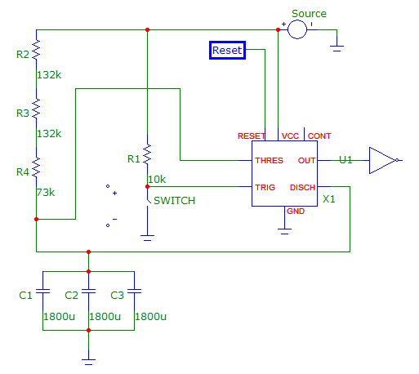

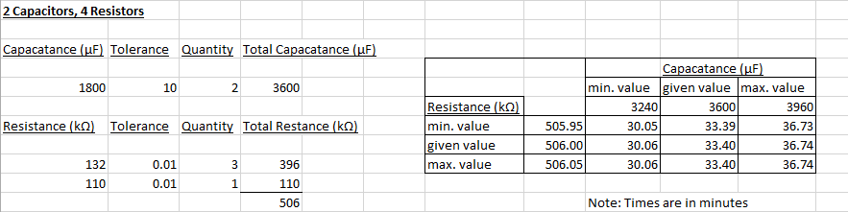

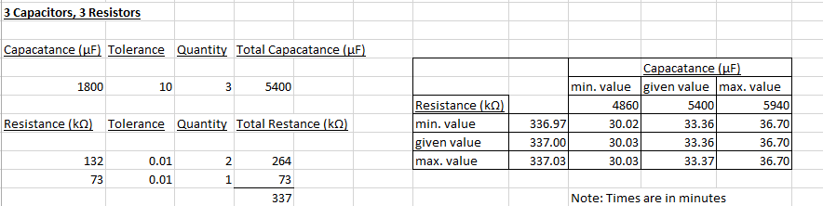

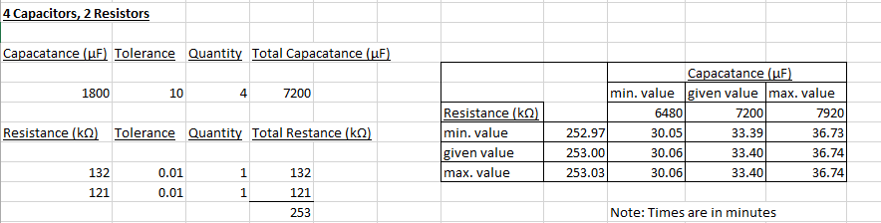

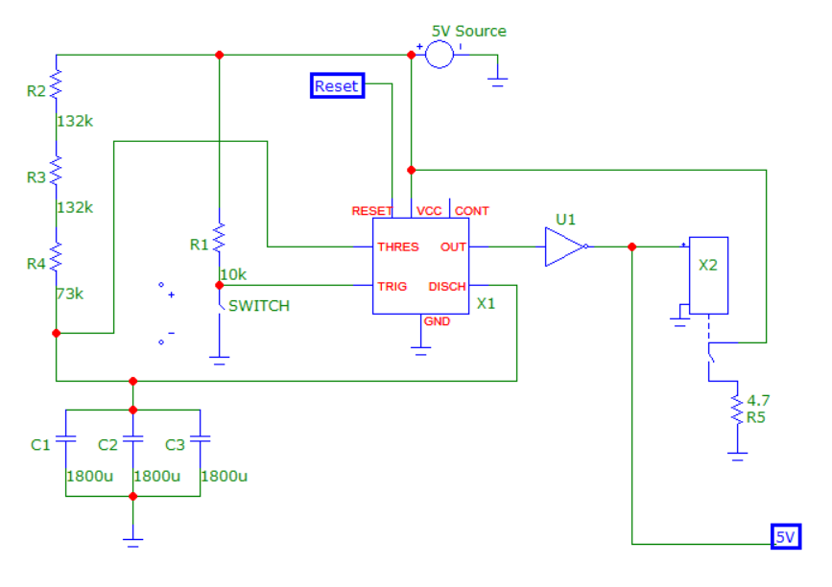

*Figure: Combined Burn Wire and 555 Timer Schematic*

This circuit is the result of combining the burn-wire and 555 timer circuits. At roughly 30 minutes, this not only begins heating the nichrome wire, but it also outputs the 5V used by one half of the PCB’s power plane. [22]

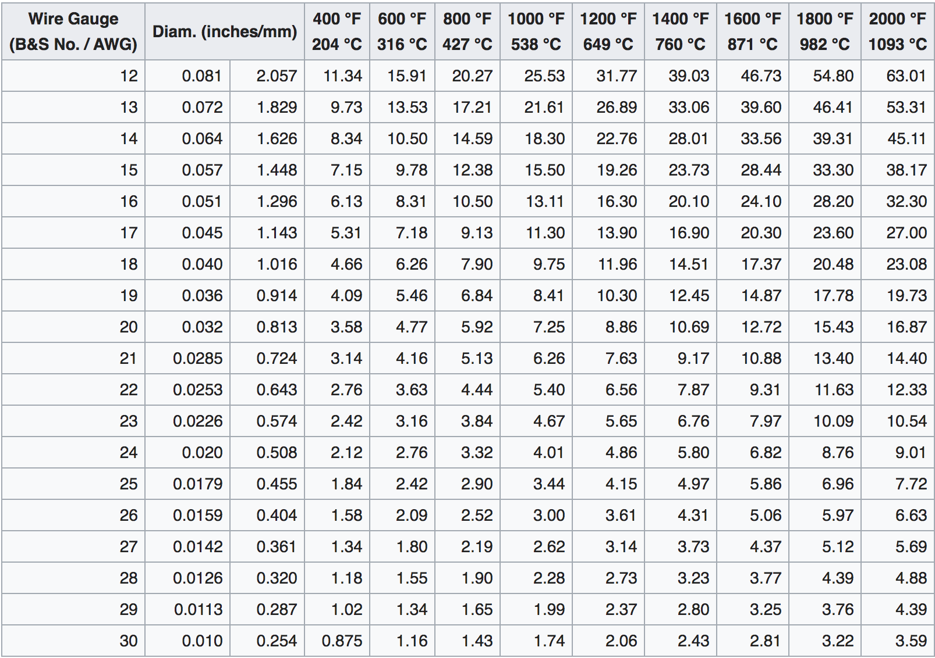

Figure: *Current (A) vs. temperature characteristics, straight wire.*

Above is a table showing the current vs temperature of different gauges of nichrome wire, from the largest being 12 gauge (AWG) all the way to the smallest of 30 gauge. For our CubeSat, we need a very thin wire, requiring not much voltage needed for the wire to be able to burn. Therefore, we shall use a wire with a gauge from 28-30, as the current required to bring the wire to its melting point is just under 2.5 Amps. With a battery source of 5 Volts, the resistance required is about 2 Ohms. [23]

# **4. Prototype Validation Plan**

## 4.1 Prototype Concept

For our prototype, after the layout of the boards is designed, we plan to order the boards and print them overseas though a company affiliated with CSA. [24] After they are delivered, we will be building our first prototype ourselves. In order to save costs, we plan on ordering alternative, non space rated parts for the first prototype and appropriate testing. After that testing is completed, we will be revising our design based on our results. We will also be collaborating with other parties involved with the cubesat project to share our results and analyze theirs in order to ensure our designs are compatible.

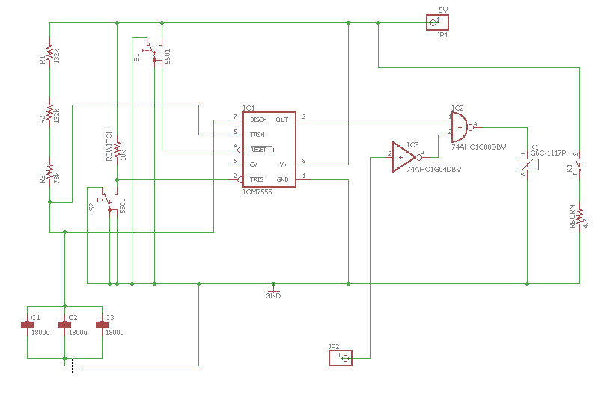

*Figure: First Iteration of Top-Board Eagle Schematic*

## This schematic shown above is the combined burn-wire and timer circuits designed in Eagle. The JP1 pin represents the via to connect the circuit to the power plane, and JP2 is a connection to the OBC to activate the burn-wire circuit. The ground symbol will be another via connected to the ground plane.

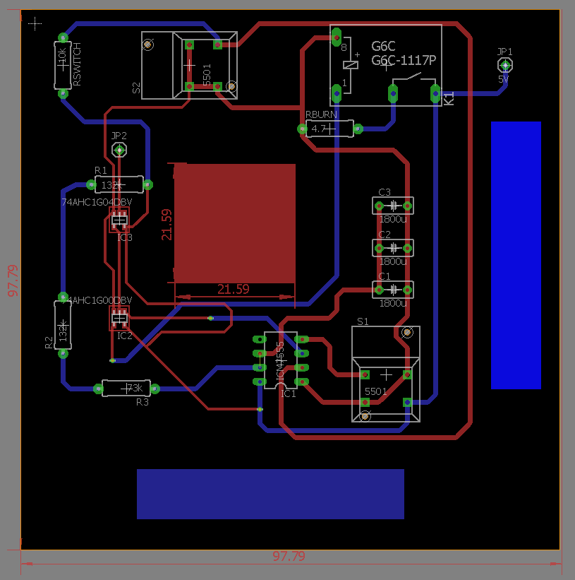

*Figure: First Iteration of Top-Board PCB*

This is an early iteration of our top PCB board. The two colours of routes each represent one of the two signal layers associated with this PCB. The red square will be cut out in order to allow the z-axis magnetorquer on the lower board to pass through. The radius of the magnetorquer is expected to be ~20mm and the cutout has been slightly increased from this value to accommodate. The blue rectangles represent the x and y axis magnetorquers located on the top board. The length of the magnetorquers has not yet been determined by the ADCS team so extra space has been reserved for them. Once we acquire the finalized values, and begin testing our board layout may change. In addition to the z-axis magnetorquer, the lower board will also hold our gyroscopes and GPS. We have opted not to design this board at this stage, as we will soon be switching from EAGLE to Altium, and they use different component libraries. We also plan on finding larger logic gates in Altium to allow for larger routes to be incorporated. Here, we reduced the diameter in those regions to make the connections easier to see. In the future, we will need to test how much interference our boards generate and apply iterations to attenuate these issues. We may end up adding decoupling capacitors to prevent crosstalk between channels, and by adjusting the distance between board layers to create interplane capacitance. Decoupling capacitors can be used to reduce crosstalk for lower frequency signals, especially before a via. However, they do not work on the higher frequencies that will be used by our GPS, which is where interplane capacitance must be used. This can be generated by placing ground and power planes very close together. [25] This exact distance will be determined during our testing phase.

## 

## 

## 

## 

## 

## 4.2 Budget/Parts List Details

Each student is provided with a budget of $75.00 to put toward their capstone assignment, resulting in a total of $300.00. However, an additional budget will be provided by CSA in order to afford the special space-rated components required in order for the CubeSat to function. [26]

* 3x Custom Made Magnetorquers
* 1x Texas Instruments SE555 Timer, Part number: M38510/10901BPA
* 3x AVX Corp. 1.8mF Capacitor, Part number: M39006/25-0192
* 2x International Resistive (IRC) 132kΩ Resistor, Part number RBR53L13202BR
* 1x International Resistive (IRC) 72kΩ Resistor, Part number RBR54L8301TR
* VEN0.25NT - VECTRAN - ¼” NATURAL - 5 FT CUTS
* NICHROME 60 WIRE 30 AWG RW0279 - 25 FT 0.11 OZ RESISTANCE
* 2x 9.8 cm by 9.8 cm four-layered PCB

# **5. Team Member Contribution**

Below is a list of tasks completed by the team members over the course of the semester:

**James Sands**

* Brainstormed with group over Discord to finalize the Block Diagram
* Viewed recommended Webinars 1, 11, 10, 2, 8, 7
* Read about changes to the CubeSat structural design
* Read Powerpoint PDR_PowerPoint_Modified_NM.pptx
* Research Monopole Antenna
* Researched burn wires, one vs multiple
* Researched MAD_1801_Final.pdf from interface.xlsx
* Researched Cubesat Attitude Determination via Kalman Filtering of Magnetometer and Solar Cell Data document
* Created antenna burn wire circuit with Keith using MicroCap
* Researched Coarse Sun Sensing for Attitude Determination of a CubeSat document
* Finalized antenna burn wire circuit
* Researched advantages and disadvantages of nichrome wire
* Researched photodiode_angle_analysis document

**Patrick Zwinkels**

* Worked with group to create block diagram of CubeSat boards
* Watched recommended webinars
* Researched information on grounding circuits
* Completed webinars
* Read interface document
* Created PC 104 presentation
* Researched data bus systems (SPI, I2C, etc.)
* Reformatted wiring interface document
* Researched picoblade implementation
* Selected connection methods for gyroscopes and magnetorquers
* Researched Nichrome wire specifications for burn-wire circuit
* Found voltage requirements for many major components including battery supply

**Andrew Wong**

* Relayed information and minutes from previous meeting to members who were not present
* Helped prepared diagrams and presentations for upcoming meetings
* Watched recommended webinars
* Researched 555 timers and other alternatives, as well as their applications
* Determined necessary mode and external components for timers for cubesat application
* Began reviewing general documents on OBC and ADCs
* Designed circuit for the timer using MicroCap
* Added all created documentation and reference documents to GitHub
* Reached out to ADCs team about component voltage and current requirements

**Keith Mody**

* Helped group create block diagram over video chat
* Watched recommended webinars
* Researched information on PC 104 stack
* Watched remaining webinars
* Researched high frequency board design
* Created powerpoint on high frequency board design
* Researched antenna burn wire background information
* Created antenna burn wire circuit
* Reviewed GitHub documentation
* Researched nichrome wire properties
* Finalized antenna burn wire circuit
* Reviewed Attitude Determination and Control Systems report

As stated in our proposal, our goal was to have each member contribute to each aspect of the project but by having a designated leader for each facet of the project, that person can more effectively collect our research and document it in order for the other members to reference it later on. Revisions to the boards were made and the roles were changed. Andrew was responsible for researching the GPS, however, the GPS has been deemed unnecessary for our final design. However, it may be included in our test models in order to learn how such systems operate. Andrew is now researching the magnetorquers with Keith and acting as Outreach Coordinator*,* Andrew has successfully lead the prototyping stage. Keith also spent a bit of time researching the PC 104 stack with Patrick. James is responsible for the gyroscope and has assisted with the MicroCap circuits.

**6. References**

[1] A.Wong, J.Sands, K. Mody, and P. Zwinkels, “Cubesat Boards Electronic Design,”

Western University, London, Canada, 2019.

[2] “What Is a CubeSat.” *Canada.ca*, 27 Nov. 2018,

[www.asc-csa.gc.ca/eng/satellites/cubesat/what-is-a-cubesat.asp](http://www.asc-csa.gc.ca/eng/satellites/cubesat/what-is-a-cubesat.asp).

[3] “What Is the Canadian CubeSat Project.” *Canada.ca*, 5 Dec. 2018,

[www.asc-csa.gc.ca/eng/satellites/cubesat/what-is-the-canadian-cubesat-project.asp](http://www.asc-csa.gc.ca/eng/satellites/cubesat/what-is-the-canadian-cubesat-project.asp).

[4] Canadian Space Agency, “Webinar archive CSA group.” *CSAGroup.org*, Oct. 2019,

https://www.csagroup.org/article-category/webinars/

[5] Dr. Jayshri Sabariathan (private communication), 2019

[6] GitHub. (noreply@github.com) “[GitHub] @nmitch6 has invited you to join the

@cubesat-project organization,” Oct. 22, 2019

[7] Lauren Flanagan (private communication), 2019

[8] Dr. Jayshri Sabariathan and Dr. Matt Cross, “Preliminary Design Review,” Western

University,London, Canada, Tech. Rep. CCP-WAC-PRD-PPT1, 2019

[9] Shaemus Tracy. ([Stracy6@uwo.ca](mailto:Sracy6@uwo.ca)) “ADC requirements,” Nov. 20, 2019.

[10] Nicholas Mitchell, (private conversation), 2019

[11] A. Weiler, A. Pakosta, and A. Verma.”High-Speed Layout Guide,” Texas Instruments,

Dallas, USA, Tech. Rep. SCAA082A, 2017

[12] Electrical Engineering, Stack exchange, “Splitting Power Planes on PCB,” June 2017,

<https://electronics.stackexchange.com/questions/305787/splitting-power-planes-on-pcb>?

bclid=IwAR3hZpm5qFYLFylsCkx64N6JcOj1k_YBH0GBI3dY0NnwZaVhZl7lPGAzZ

[13] How it works, How to Mechatronics, “555 IC Timer - Working Principle, Block Diagram,

Circuit Schematics,” February 2018,[https://howtomechatronics.com/how-it-](https://howtomechatronics.com/how-it-works/electronics/)

[works/electronics/](https://howtomechatronics.com/how-it-works/electronics/)555-timer-ic-working-principle-block-diagram-circuit-schematics/

[14] Timers, Arrow Electronics, “555 Fairchild Semiconductor,” August 2016,

<https://www.arrow.com/en/products/lm555cn/fairchild-semiconductor>

[15] Calculators, Ohms Law Calculator, “555 Astable Circuit Calculator,”

http://www.ohmslawcalculator.com/555-astable-calculator

[16] Calculators, Ohms Law Calculator, “555 Monostable Circuit Calculator,”

http://www.ohmslawcalculator.com/555-monostable-calculator

[17] Catalog No. RW0279, Nichrome 60 Wire, TEMCO Industrial, Fermont, CA

[18] Tae-Yong, Chae, Bong-Geon, and Hyun-Ung, “Development of 6 U CubeSat's Deployable

Solar Panel with Burn Wire Triggering Holding and Release Mechanism,” International

Journal of Aerospace Engineering

[19] Nicholas Mitchell, (private conversation), 2019

[20] CRC Registrar. ([registrar@cmc.ca](mailto:registrar@cmc.ca)) “CMC Account Confirmation,” Nov. 26, 2019.

[21] P. Kane, Tech Tips, Jameco Electronics, “How to configure 555 timer IC,” 2018.

https://www.jameco.com/Jameco/workshop/TechTip/555-timer-tutorial.html

[22] Category Archives: Formulas, Conversions & Calculations, Pelican Wire, “Formulas

Resistances,”<https://web.archive.org/web/20120920075813/http://www.pelicanwire.com/category/formulas-resistance/>

[23] VEN0.25NT - Vectran - 1/4’ - Natural - 5 ft cuts, Vectran 1/4" Natural - WireCare.com*,*

Lafayette, New Jersey

[24] Nicholas Mitchell, (private conversation), 2019

[25] PBC Design, Altium, “Interplane Capacitance and PCB Stackup,” April 2019,

<https://resources.altium.com/pcb-design-blog/interplane-capacitance-and-pcb-stackups?fbclid=I>

R0sTjGM_xtbSTsHIKIAhiiH1nYzCsT8CqkSLEblJVfcoqdM4I0JOq_5VY8

[26] Tech Briefs, Nasa, “Launch Tie-Down and Release Mechanism for CubeSat Spacecraft,”,

<https://www.techbriefs.com/component/content/article/tb/techbriefs/mechanics-and-machinery/2>

810?fbclid=IwAR1eG6g7_Xa2PveTf4j_7jugb5iazAAnYhevsVTS30I0x2KNdBDPJAzNUtY.

# **7. Gantt Chart**

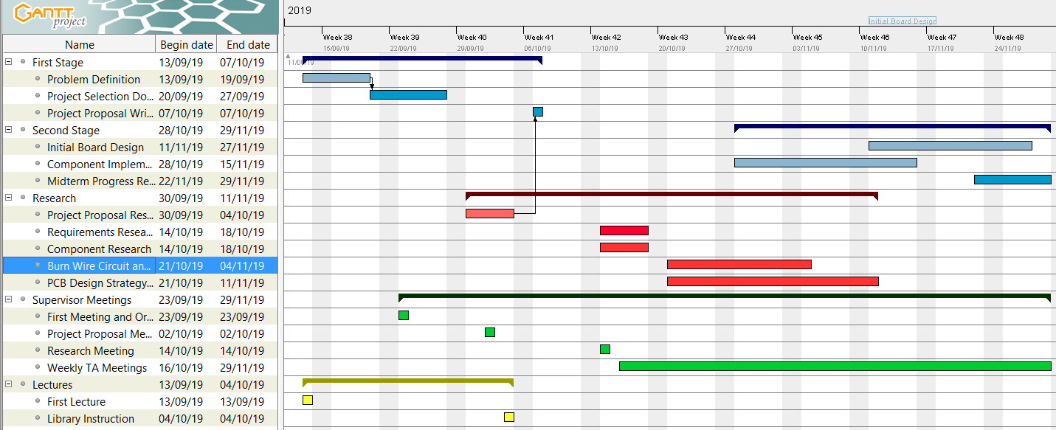

The Gantt chart displays the work that has been completed up until this point and that has been planned for the future. We have decided to call all work done between the project proposal and this midterm report “phase two.” Each aspect of the project is color-coded for easy viewing. Blue represents our written work and documentation, as well as adding to our CubeSat wiki on GitHub. Red represents research completed in order to understand the CubeSat systems and how best to construct them. It also contains the testing work we have performed to verify our circuits. Up to this point, most research has been on the burn-wire circuit, 555 timer, and general PCB design for high-frequency, multilayered boards. Green represents group meetings for collecting and sharing information amongst all members. Prior to phase two, we would schedule meetings whenever we felt they were needed. However, now that we have met our capstone supervisor, and begun breaking up research topics, we are holding weekly meetings to discuss our findings. Finally, the yellow represents our classroom lectures. We have not had any of these during phase two. In the future during “phase three,” we will be continuing our weekly meetings with our supervisor. We will also likely add a new category to our Gantt chart specifically for testing purposes, as phase three will require many revisions to our designs. We have one more lecture scheduled for the year. Documentation will be important in phase three because all components must be easy to pick up and understand for future designers of this CubeSat. We will be making weekly additions to our wiki to stay on track.